
Year 10 - 2016

Investigation 4

Semester Two Term 4

Linear Equations, Parallel and Perpendicular lines

This investigation will be completed in class with help and guidance provided for the initial question. You will then complete a second question to fully test your understanding of linear relationships. No guidance or hints will be provided for this. You may have one A4 note page and a calculator.

AIM: In this assessment you will be investigating the triangle formed from three linear equations and calculate its area in square units. The formula to find the area of a triangle is:

Area = ½ x base x perpendicular height
Mark: /22

%

Name: ______________________________________________ Class: __________________

- Calculate the area of the triangle formed (in square units) from the following three linear equations:

$y=x+4$ $y=3x$ $y=-x+4$

First, find the gradient and y intercept of all three lines:

Equation | Gradient = $\frac{rise}{run}$ | Y intercept
$$y=x+4$$ | 1 | 4
$$y=3x$$
$$y=-x+4$$

Two of the lines must be perpendicular.
$y=x+4$ and ___________________________ are perpendicular because their gradients are the

negative reciprocal of each other. These lines will cross at right-angles. The gradients of perpendicular lines multiply to make -1. $m_{1}×m_{2}=-1$

Next; graph the lines on the axes provided

$$y=3x$$
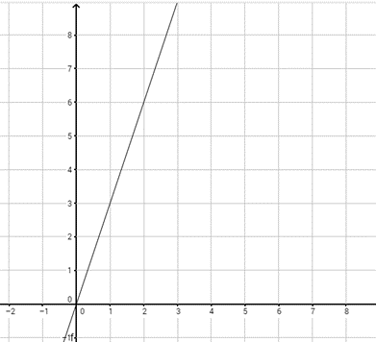

What are the coordinates of the points where the lines cross?

(0,4) ( _ , _) and ( _ , _ )

Identify the triangle, the right angle and the sides you need to measure.

For the first line from (0,4) to (2,6):

Length = $\sqrt{{\left(x_{2}-x_{1}\right)}^{2}+{\left(y_{2}-y_{1}\right)}^{2}}$

Length = $\sqrt{{\left(2-0\right)}^{2}+{\left(6-4\right)}^{2}}$

Length = $\sqrt{{\left(2\right)}^{2}+{\left(2\right)}^{2}}$

Length = $\sqrt{4+4}$

Length = $\sqrt{8}$

Length = 2.83 square units (to 2 d.p)
In this case, the lines we need to measure run from:

(0,4) to (2,6) and (0,4) to (1,3)

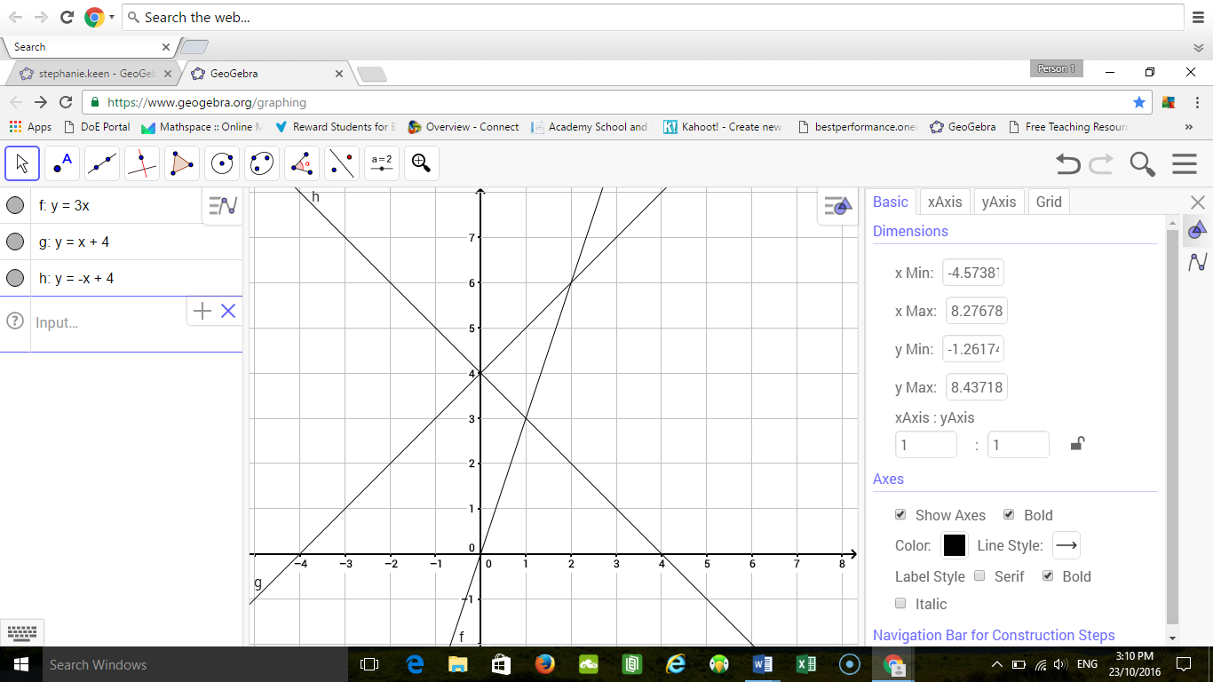

For the second line from (0,4) to (1,3)

Length = $\sqrt{{\left(x_{2}-x_{1}\right)}^{2}+{\left(y_{2}-y_{1}\right)}^{2}}$

Length = $\sqrt{{\left(1-0\right)}^{2}+{\left(3-4\right)}^{2}}$

Length = $\sqrt{{\left(1\right)}^{2}+{\left(-1\right)}^{2}}$

Length = $\sqrt{1+1}$

Length =$\sqrt{2}$

Length = ___________ square units (to 2 d.p)

The area of the triangle is therefore:

Area = ½ x ___________ x 2.83 = ___________________ square units.

- Calculate the area of the triangle formed from the following three linear equations:

$y=-2x+2$ $y=\frac{1}{2}x+2$ $y=x-1$

[6]
Equation | Gradient | Y intercept

Graph the three equations [6]

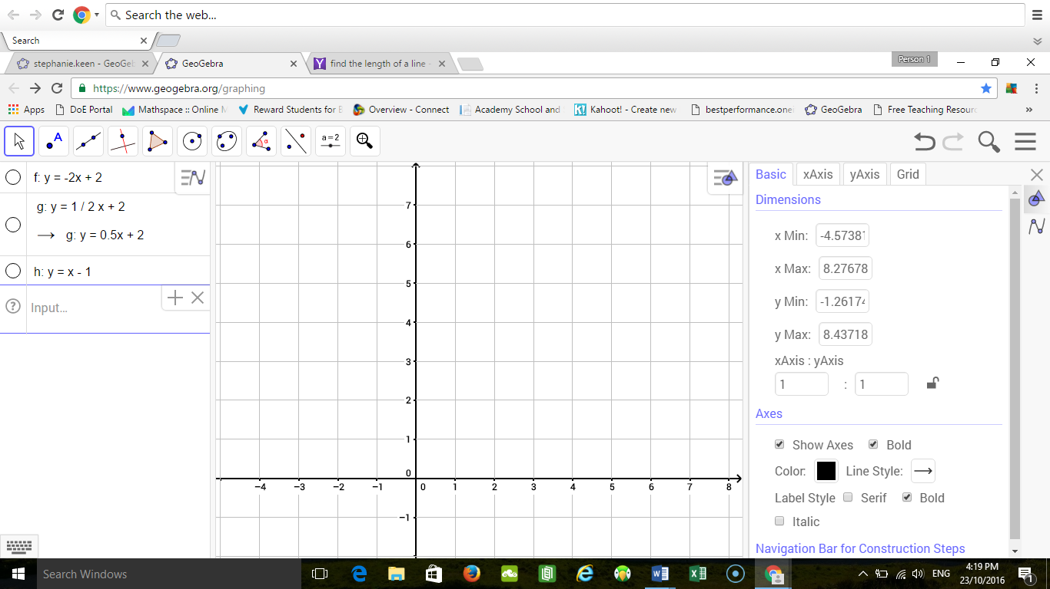

Identify the triangle formed on the graph [1]
List the coordinates of the points where the lines cross to form the triangle. [3]

Find the lengths of the lines which meet at right angles [4]

Hint: Length = $\sqrt{{\left(x_{2}-x_{1}\right)}^{2}+{\left(y_{2}-y_{1}\right)}^{2}}$

What is the area of the triangle formed in square units? [2]

Area = ½ x base x perpendicular height

END OF INVESTIGATION

